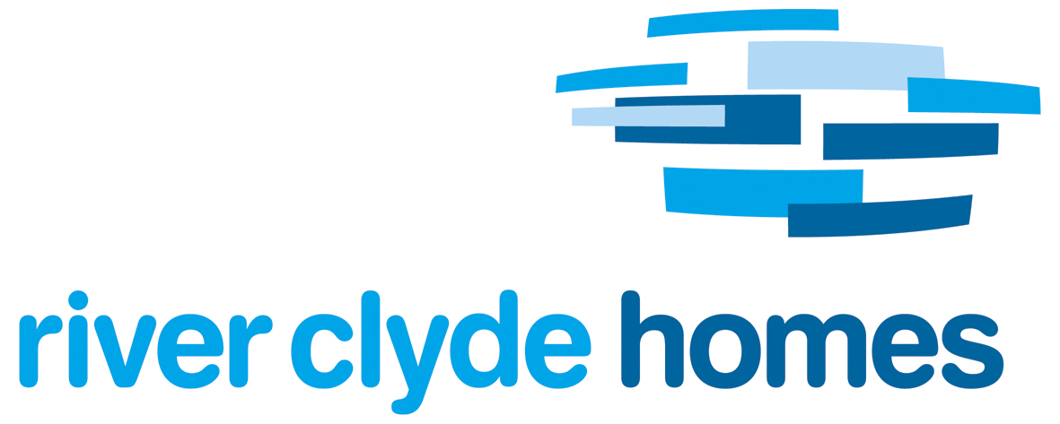
Mutual Exchange Application Form

One form to be completed for each tenancy making the application.

Tenant Details
Tenant Name
Tenant Address
Tenant Contact Details
Tenant Landlord name and address

Tenant Family Details (list everyone who will be moving into your new home)
 | Full Name | Date of Birth | Marital Status | Relationship to Tenant | Currently living with tenant Yes/No | Relevant medical condition  Yes/No
1
2
3
4
5
6
7
8

Current Tenancy Details
Your Tenant Reference | Your tenancy Start Date | Number of Bedrooms in current home | Property Type i.e. flat | Is your tenancy Medically Adapted Yes/No | Rent Charge and frequency i.e. weekly | Current balance on your rent account

Exchanging Tenant Details
Tenant Name
Tenant Address
Tenant Contact Details
Tenant Landlord name and address
Tenant Landlord contact details

Exchanging Tenant Current Tenancy Details
Number of Bedrooms in house | Tenancy Type i.e. tenement flat | Is this Tenancy Medically Adapted Yes/No | Rent Charge and frequency i.e. weekly

Reason for Application (please state your reason for seeking this mutual exchange

Tenant Declaration

I declare that the information provided within this application is true and understand that both parties to this mutual exchange should ensure that the house that they are moving to fully meets their requirements and expectations. I agree that River Clyde Homes will not be responsible for repairs or replacement to fittings, fixtures, adaptations or improvements that have been carried out by the outgoing tenant.

Tenant Signature ……………………………………………………..Date……………………….

Tenant Signature ……………………………………………………..Date……………………….

For RCH Official Use
Survey Date | Pass Survey Y/N | Date Officer Checklist completed | Date Exchange Approved | Date Outcome letter sent

Housing Officer Signature ……………………………………………Date……………………….

